Mockito Hands-On Exercises

# Exercise 1: Mocking and Stubbing Scenario:

You need to test a service that depends on an external API. Use Mockito to mock the external API and stub its methods.

# Steps:

1. Create a mock object for the external API.
2. Stub the methods to return predefined values.
3. Write a test case that uses the mock object. Solution Code: import static org.mockito.Mockito.*; import org.junit.jupiter.api.Test;

import org.mockito.Mockito; public class MyServiceTest

{

@Test public void testExternalApi()

{ ExternalApi mockApi = Mockito.mock(ExternalApi.class); when(mockApi.getData()).thenReturn("Mock Data");

MyService service = new MyService(mockApi);

String result = service.fetchData(); assertEquals("Mock Data", result); } } **Output:**

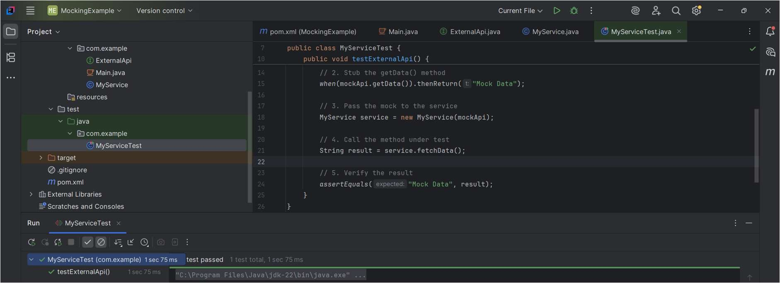

# Exercise 2: Verifying Interactions

**Scenario**: You need to ensure that a method is called with specific arguments.

# Steps:

1. Create a mock object.
2. Call the method with specific arguments.
3. Verify the interaction.

# Solution Code:

import static org.mockito.Mockito.*; import org.junit.jupiter.api.Test; import org.mockito.Mockito;

public class MyServiceTest {

@Test public void testVerifyInteraction() {

ExternalApi mockApi = Mockito.mock(ExternalApi.class); MyService service = new MyService(mockApi); service.fetchData();

verify(mockApi).getData(); } }

# Ouput:

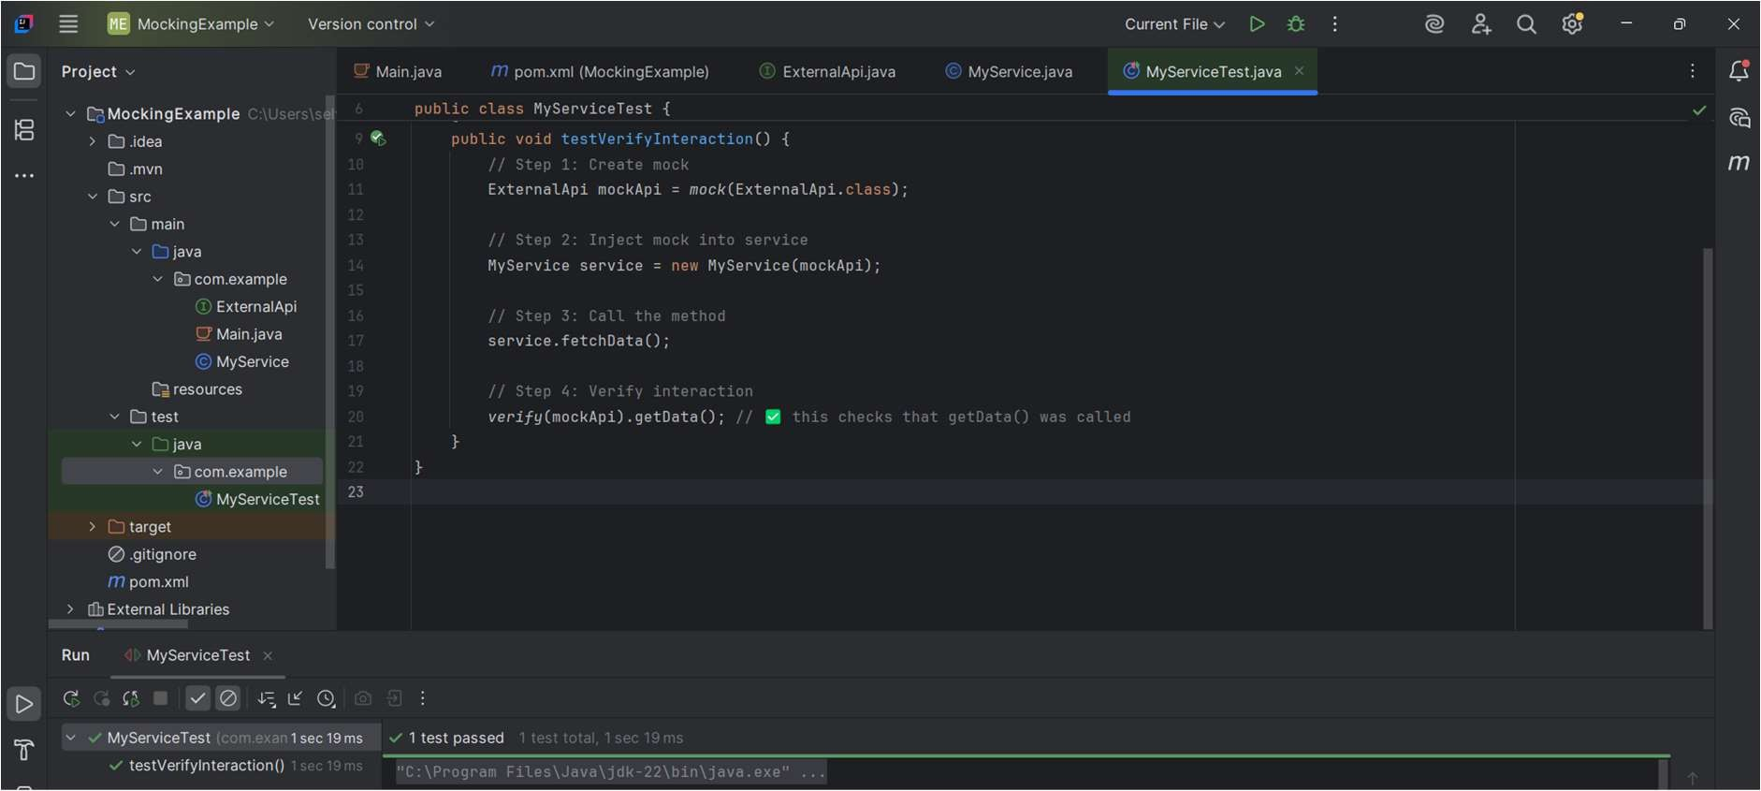

**Exercise 3: Argument Matching**

Scenario: You need to verify that a method is called with specific arguments.

# Steps:

1. Create a mock object.
2. Call the method with specific arguments.
3. Use argument matchers to verify the interaction

# Output:

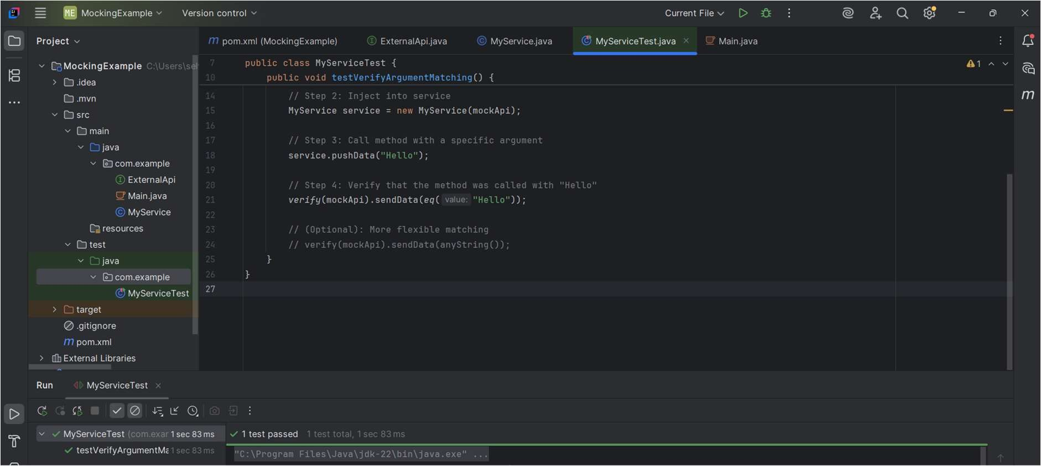

**Exercise 4: Handling Void Methods**

Scenario: You need to test a void method that performs some action.

# Steps:

1. Create a mock object.
2. Stub the void method.
3. Verify the interaction.

# Output:

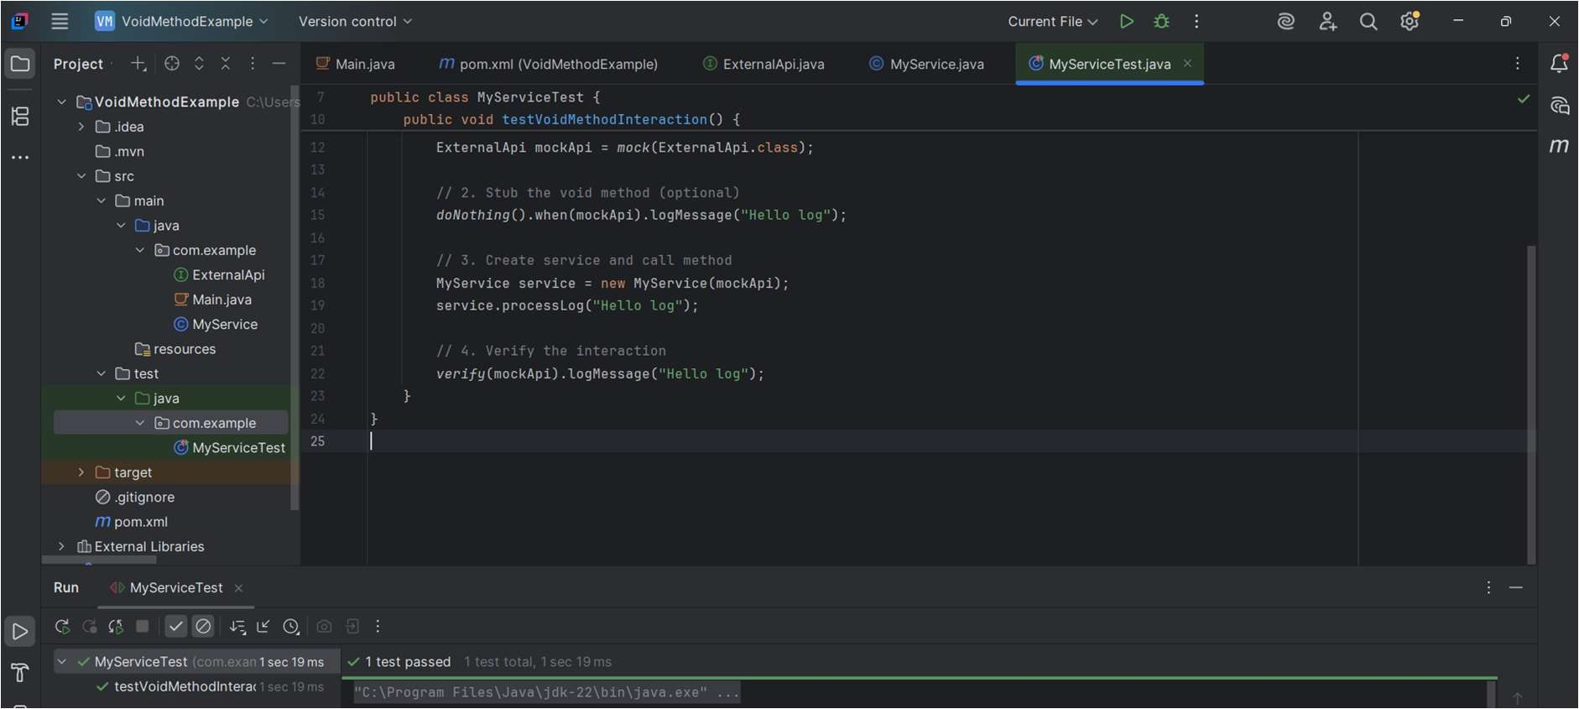

**Exercise 5: Mocking and Stubbing with Multiple Returns Scenario:** You need to test a service that depends on an external API with multiple return values.

# Steps:

1. Create a mock object for the external API.
2. Stub the methods to return different values on consecutive calls.
3. Write a test case that uses the mock object.

# Output:

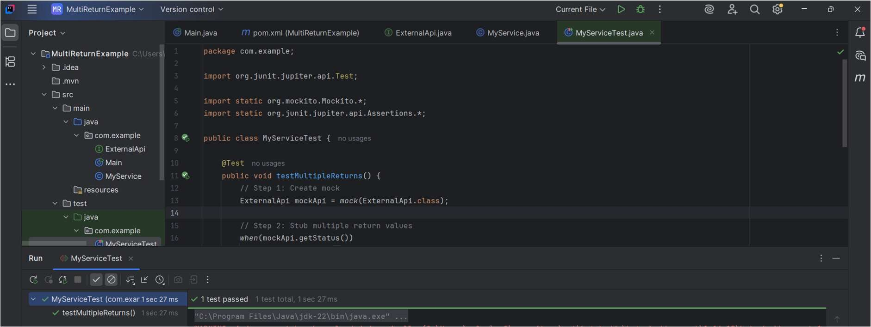

**Exercise 6: Verifying Interaction Order**

**Scenario:** You need to ensure that methods are called in a specific order.

# Steps:

1. Create a mock object.
2. Call the methods in a specific order.
3. Verify the interaction order.

# Output:

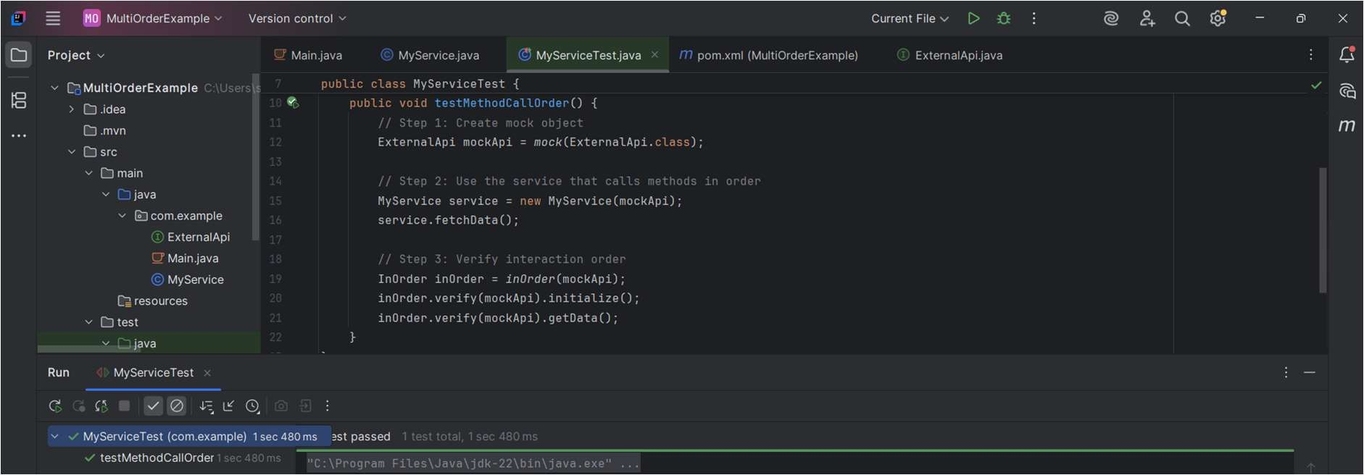

**Exercise 7: Handling Void Methods with Exceptions**

**Scenario**: You need to test a void method that throws an exception.

# Steps:

1. Create a mock object.
2. Stub the void method to throw an exception.
3. Verify the interaction

**Output:**

